**Experiment No. 1.4**

**Student Name: Rishav Kumar UID: 22MCC20039**

**Branch: MCA - CCD Section/Group: MCD-1/ Grp A**

**Semester: III Date of Performance: 13th Sep 23**

**Subject Name: DevOps Process Automation Lab Subject Code: 22CAP-745**

1. **Aim/Overview of the practical:**

Install and configure Jenkins and Java 17.

Creating admin Jenkins user and touring the Jenkins dashboard.

**Code for practical:**

* To install JDK 17, go to Apache website and download installer.
* Install it in ***Program Files>Java>Jdk 17***.
* Add bin path to environment variables of jdk.
* Check java version using command ***java --version*** in command prompt.

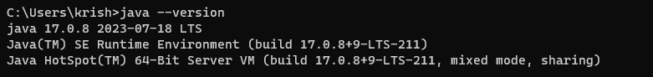

* To install Jenkins, go to *https://www.jenkins.io/download/* and install it.

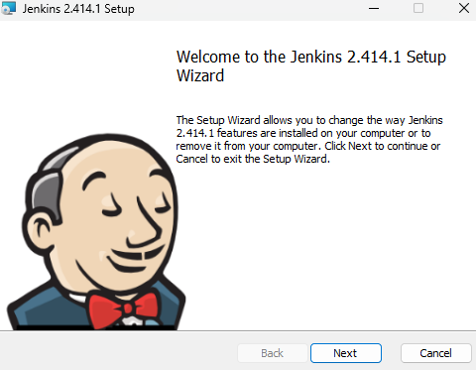

* Select run service as local user and select java path.
* Jenkins will be started at localhost://8080 by default or user can change it.
* Enter password from Program files>Jenkins>jenkins.err.log

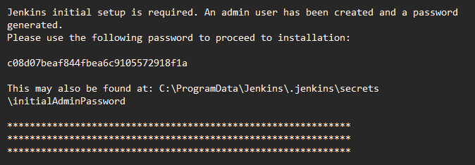

* Enter password and click on install suggested plugins.

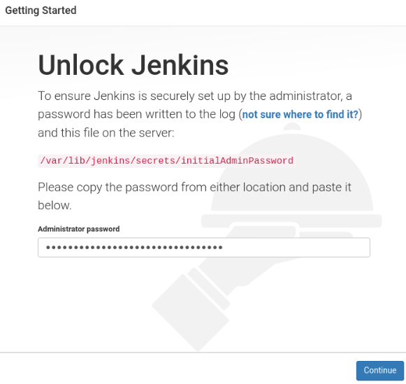

* Create admin user via entering username and password.
* To open Jenkins, enter localhost port in URL and enter username and password to login.

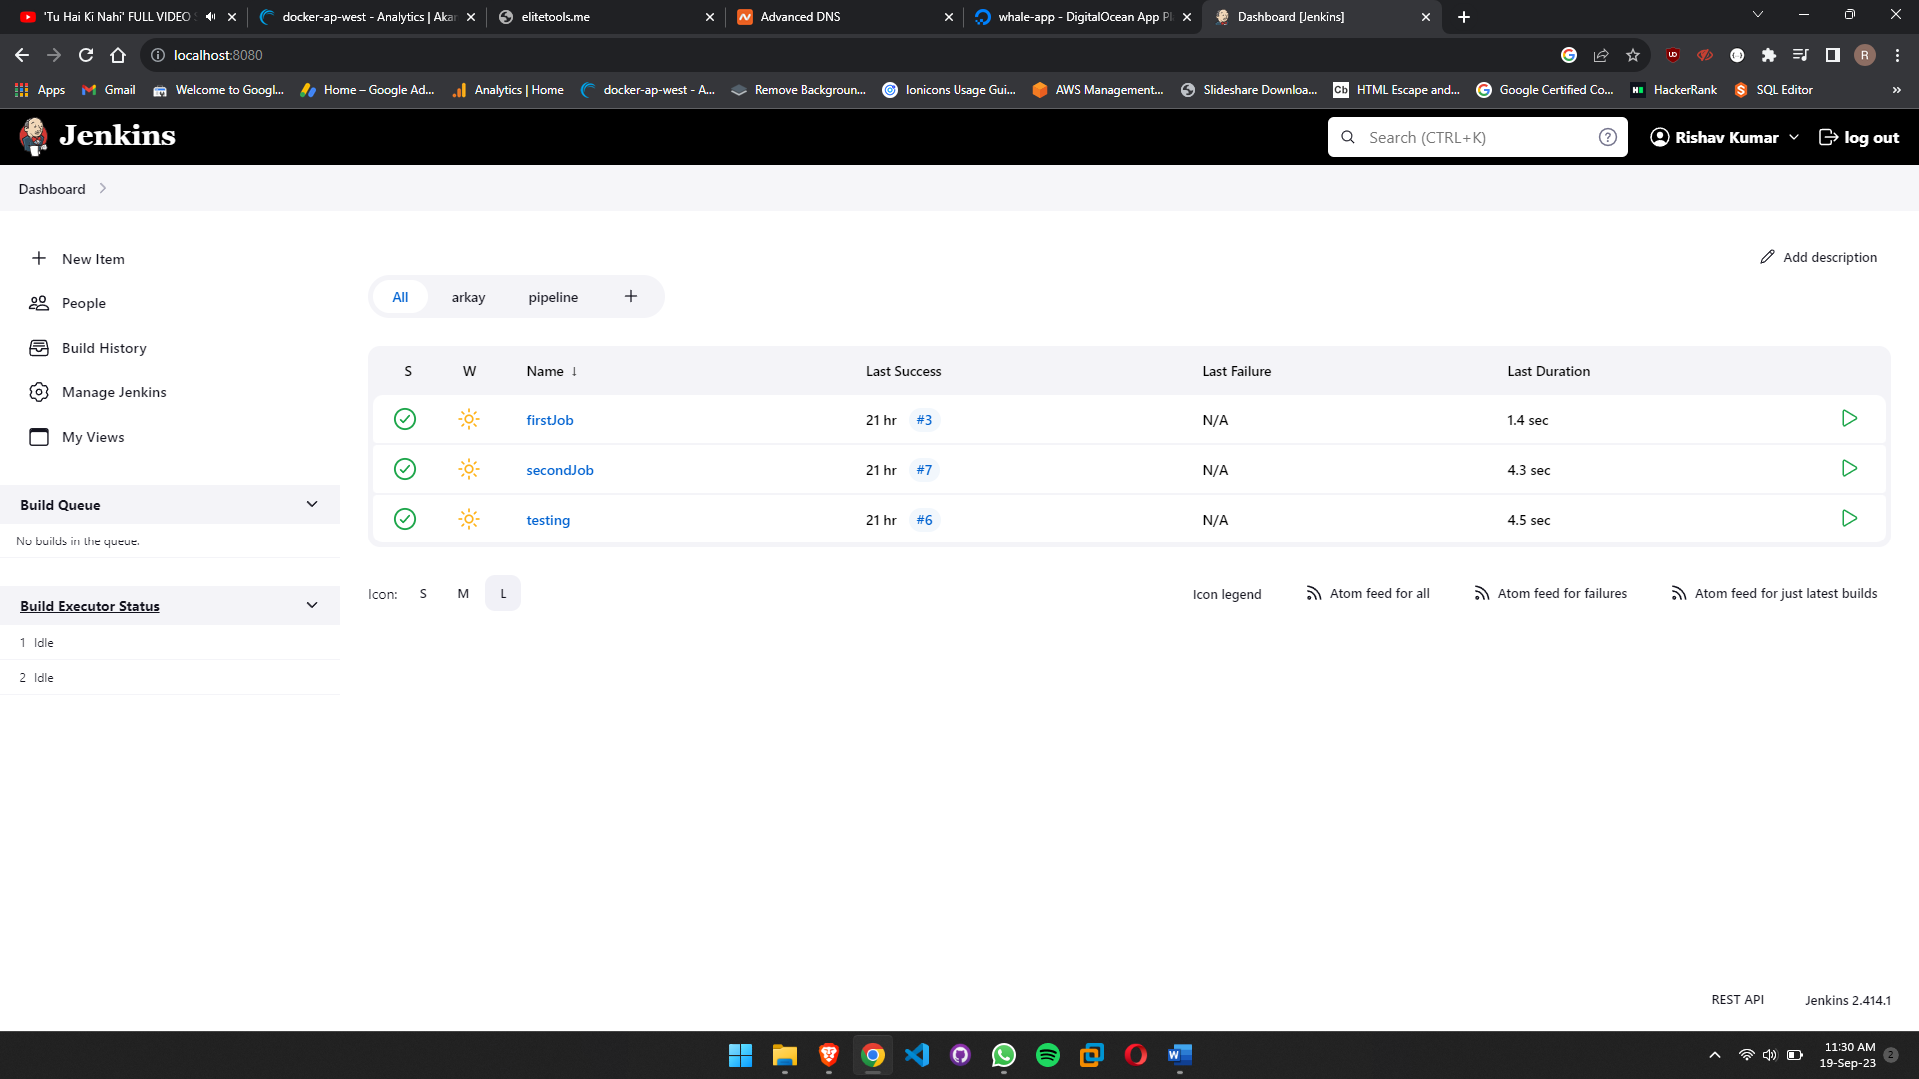

* You can add or remove plugins from Manage Jenkins from sidebar.

Main highlights of Jenkins dashboard are:

* **New Item:** To create a new job or pipeline, click on the "New Item" link. Jenkins supports various types of projects, including Freestyle projects, Pipeline projects, and more. Choose the appropriate project type and configure it according to your needs.
* **Build History:** On the dashboard, you'll see a list of recent builds for each job. The color-coded icons indicate the status of each build (e.g., success, failure, unstable, or aborted).
* **Build Queue:** The build queue section shows pending jobs that are waiting to be executed. It provides insight into the workload and helps you manage the order of job execution.
* **Manage Jenkins:** Clicking on "Manage Jenkins" in the left sidebar opens a menu where you can access various administrative options, including configuring global settings, managing plugins, and setting up security.
* **Console Output:** After triggering a build, you can view the real-time console output by clicking on the build number or name. This is crucial for troubleshooting and understanding the progress of a job.
* **Plugins:** Jenkins supports a wide range of plugins to extend its functionality. You can manage and install plugins through the "Manage Jenkins" section.
* **User Menu:** In the top right corner, you'll find a user menu where you can access your user profile, change your password, and log out of Jenkins.
* **Search:** Jenkins includes a search bar that allows you to quickly find specific jobs, builds, or configuration settings.
* **Views:** You can create custom views to group and organize jobs based on criteria such as project type, team, or function. Views make it easier to navigate a large number of jobs.

**************************************** **THE END** ***********************************************